Antibody/ Antigen Diagnostic Test
Sign-Up Sheet
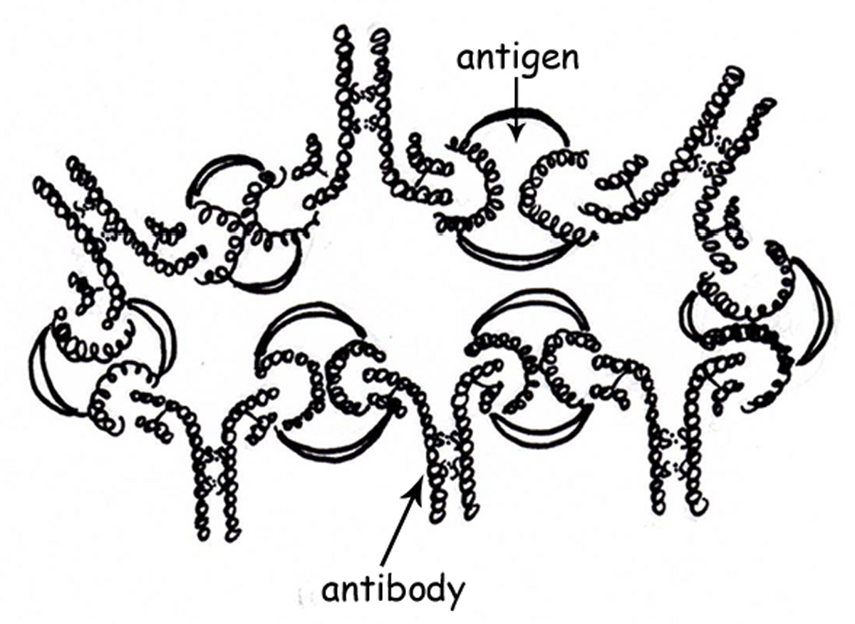

Disease/ Disorder | Name
Hepatitis B
Malaria
HIV
Syphilis
Human Pregnancy
Tumor markers for breast cancer
Tumor markers for prostate cancer
Feline heartworm test
Genital herpes
Bovine Leukemia Virus
Anthrax
Lyme disease
Arthritis
Diabetes
Y. pestis
(Black Plague)
Chicken pox

