Basic Laboratory Safety Rules
1. Follow all posted safety rules and act in a responsible, informed manner at all times.
2. Understand and follow all written and verbal instructions. Ask questions if unsure about any procedure. Be aware of potential dangers that could arise during laboratory work.
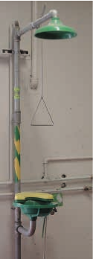
3. Before using products or equipment, carefully read labels, experimental protocols, and equipment instructions and literature. Learn where to find and how to read Safety Data Sheets (SDS).
3. No eating or drinking in the laboratory. No gum chewing. No makeup application.
4. Wear safety apparel, such as safety goggles, gloves, lab coats, and other protective clothing as necessary. Tie hair back and do not wear dangling jewelry or baggy clothing.
5. Know how to call for emergency help, and the location of a first aid kit, fire exits, fire extinguishers, eyewash, and safety showers (see Figure). Make sure nothing flammable is within 1 foot of an open flame.
6. Wash hands regularly, with soap and water, especially after working with microorganisms or chemicals.
7. Contaminated samples (chemical, biological, glass, and radioactive wastes) must be dis- posed of in appropriate containers. Do not pick up broken glass with your hands. Learn the specific methods of waste removal from your lab supervisor.
8. Label all samples and reagents clearly with the name of the item, the name of the person who prepared the sample, and the date of preparation.
9. If you are taking antibiotics, or you are pregnant or ill, report your condition to your supervisor.
10. Report spills, accidents, and injuries to your lab supervisor or safety officer immediately.

